7th Annual Mike Goss Memorial Comedy Night

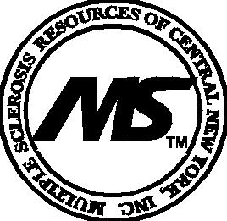
Sponsored By: Bruin Computer

benefiting
Multiple Sclerosis Resources of CNY

Friday, October 25, 2019
Barbagallo’s Restaurant - 6344 E. Molloy Rd. E. Syr 13057

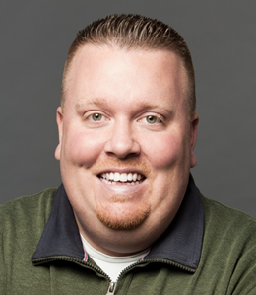
Host - RJ McCarthy Feature - Shaun Murphy Headliner - Mike Speirs
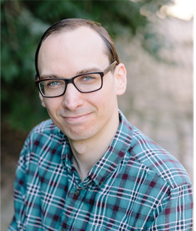
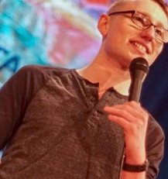

Doors open at 6:00 pm for Dinner - Show Starts at 7:30 pm
**Tickets: $ 15 Pre-Sale $ 20 at the Door
** Ticket Price Does Not Include Dinner

Raffles, 50/50 Drawing and More!!!

RJ McCarthy – is one of the hardest working comics in Syracuse. He opens regularly at the local Funny Bone Club and on stage at other clubs and venues all over NY State and beyond. When not performing comedy, RJ can be found at home watching YouTube with his dog and writing comedy bios nobody reads!

Shaun Murphy – originally from Buffalo has performed in many clubs and colleges throughout North America. He has told jokes at prestigious places like the Asheville Comedy and the Boston Comedy Festivals, the Helium Comedy Clubs to less prestigious places like a high school graduation party with a broken microphone. He has been lucky enough to feature for a diverse group of headliners such as Dave Attell, Mark Normand, Jen Kirkman and Tom Green. Shaun’s like-ability and awkwardness keeps audiences captivated whenever he performs. He currently lives in New York City with a lot of roommates and no money!

Mike Spiers - is a NYC based comedian who performs in theaters and the nation’s top comedy clubs. When he’s not headlining his own shows’ you can catch Mike touring with one of the country’s top headliners, Bob Marley. In addition to the stand up stage, Mike can also be seen acting on television and in commercials, most notably with a recurring role in the critically acclaimed Showtime series “ Escape at Dannemora,” directed by Ben Stiller.

